Cairo University Faculty of Computers and Information



**Software Engineering II**

**Software design specification document**

**2020**

|  |  |  |  |
| --- | --- | --- | --- |
| **ID** | **Name** | **Email** | **Mobile** |
| 20170077 | Belal Hamdy Ezzat | [belalhezzat@gmail.com](mailto:belalhezzat@gmail.com) | 01120171784 |
| 20170034 | Ahmed Nasr Eldardery | [megadardery@yahoo.com](mailto:megadardery@yahoo.com) | 01142078088 |
| 20170039 | Adham Mamdouh Mohammed | [Mamdouhadham57@gmail.com](mailto:Mamdouhadham57@gmail.com) | 01111404335 |
| 20170050 | Abdelrahman Mohammed Hassan | [abdookasha@gmail.com](mailto:abdookasha@gmail.com) | 01144788185 |

**Eng. Mahmoud Haddad**

Contents

Class diagram design 3

Sequence diagram design 4

Login 4

User Registration 5

Admin Registration 6

Get All Users 6

Get All Admins 7

Get All Users and Admins 7

Github repository link 8

# Class diagram design

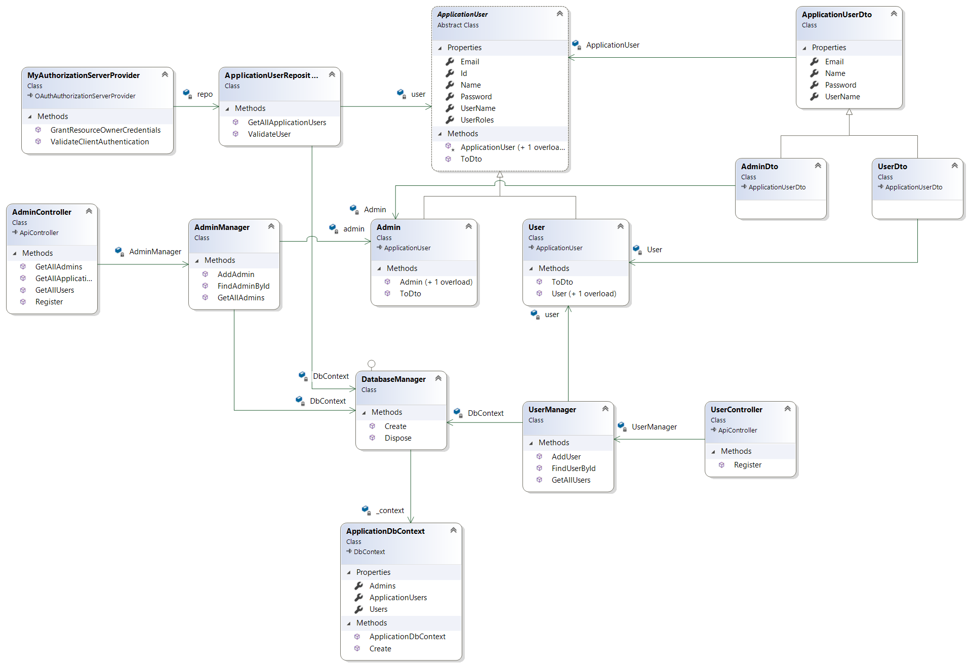

# Sequence diagram design

## Login

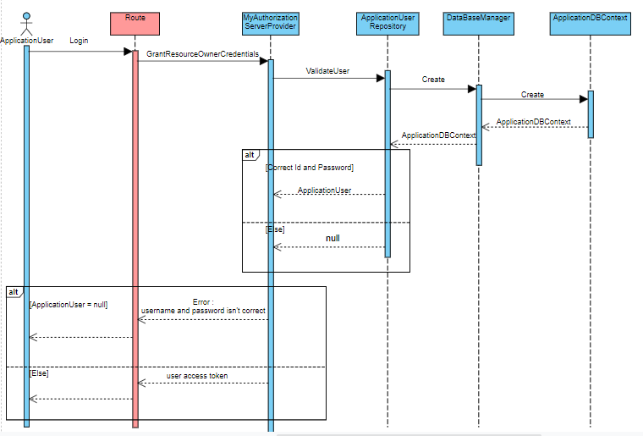

## User Registration

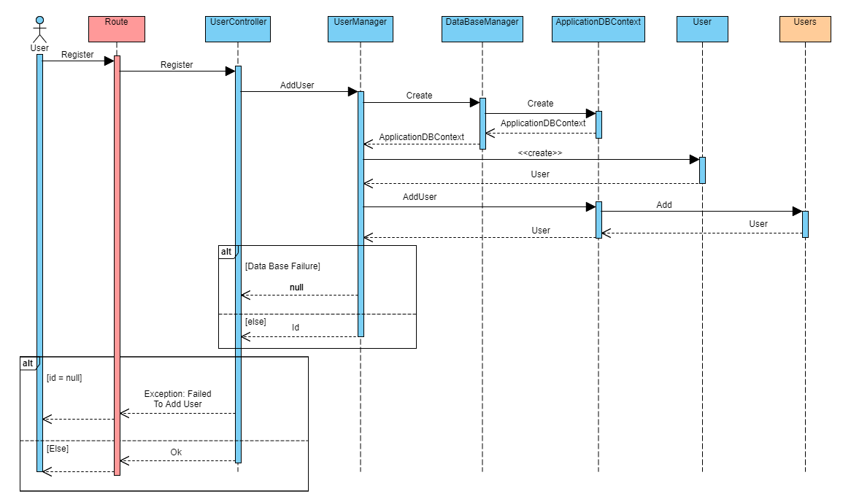

## Admin Registration

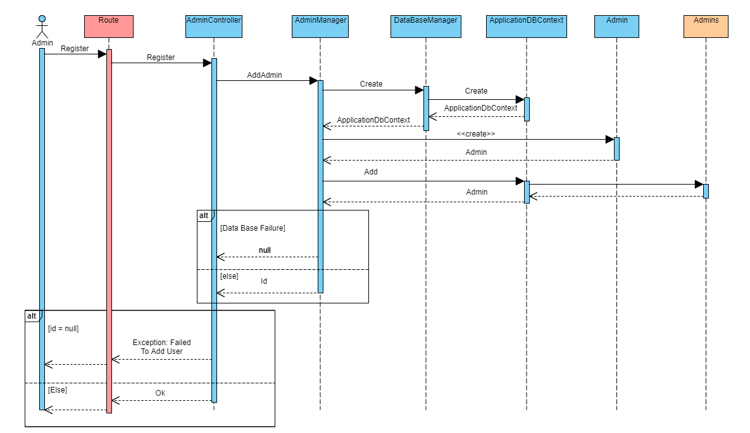

## Get All Users

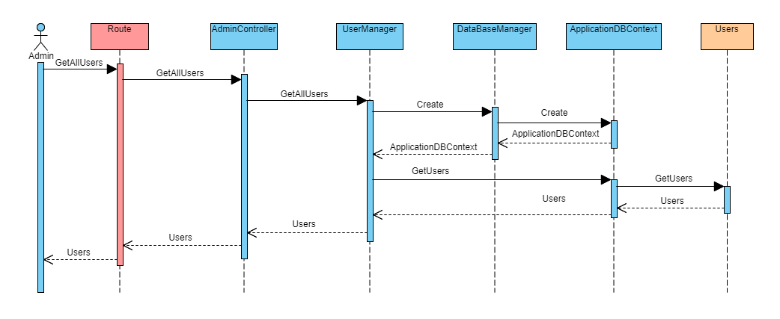

## Get All Admins

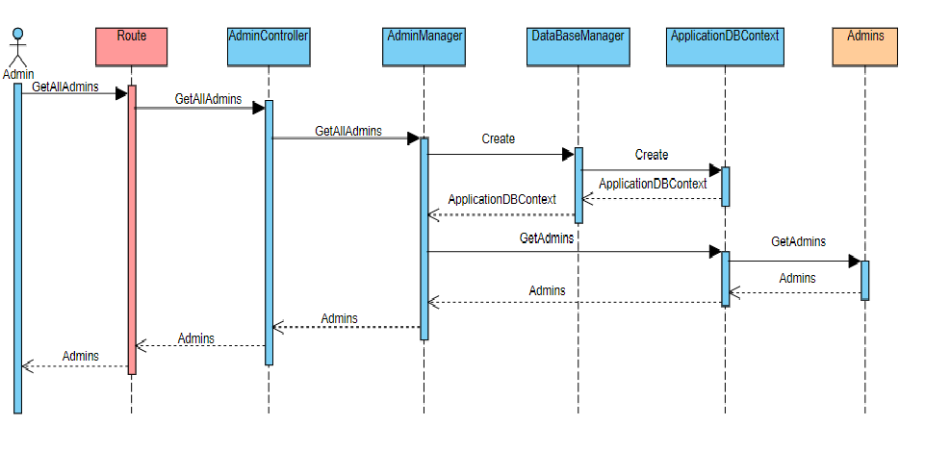

## Get All Users and Admins

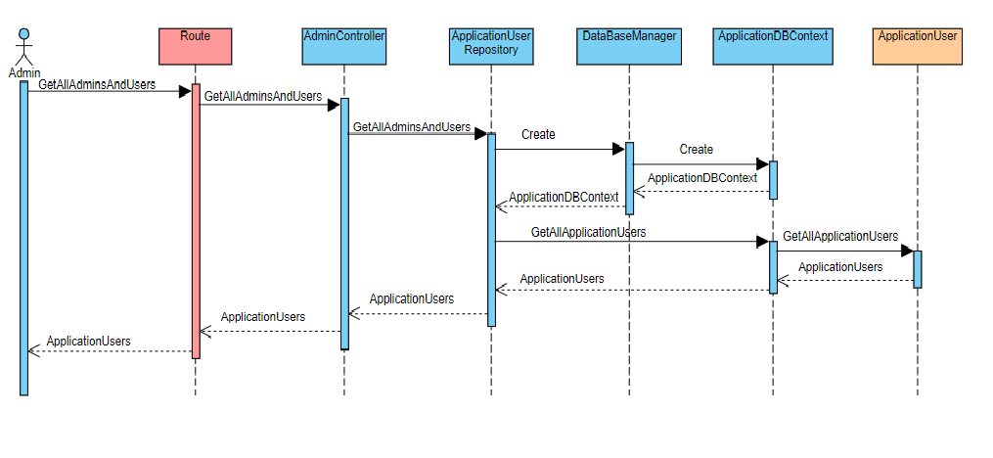

# Github repository link

* <https://github.com/adhammamdouh/FCAI-Shop/tree/master/FCAI-Shop>